Fushë Kosovë
July 2023
APRIL-JUNE REPORT 2023
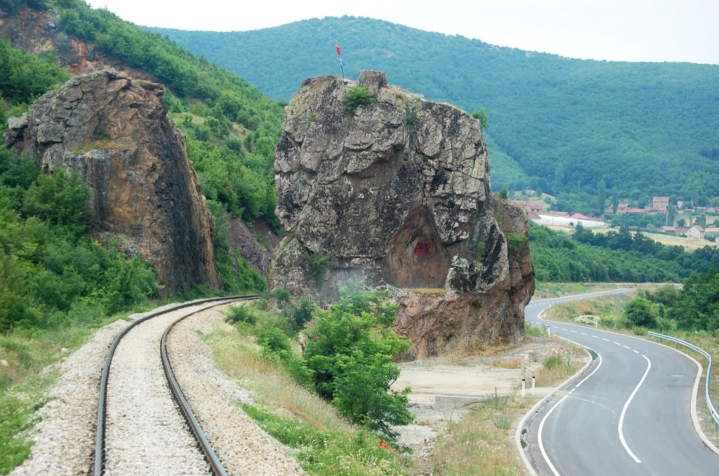
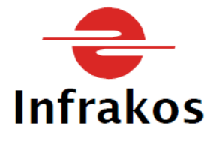
Content
1. The main activities of INFRAKOS 3
1.1 Reporting 4
1.2 The railway line 10 (ten) 6
1.3 Infrastructure maintenance 7
1.4 The organizational structure of INFRAKOS 8
2 Infrastructure Department 9
2.1 Traffic sector 9
2.2 Railway lines maintenance sector 11
2.3 Electro-technical activity sector 16
2.4 Planning, Development, Standardization and Safety Sector 17
3 Administration department 18
3.1 Personnel Sector Error! Bookmark not defined.
4 Sector for public relations and Media, Education, Protection and Safety at Work Error! Bookmark not defined.
4.1 Public and media relations 21
4.2 Education, safety and protection at work 22
5 Real-estate sector 23
6 Procurement sector 24
6.1 Capital projects from the Consolidated Budget of Kosova 25
6.2 Supply projects from the INFRAKOS Budget 25
7 Internal controller 25
8 Financial performance of INFRAKOS 27
8.1 The income 28
8.2 Expenditures 29
9 Judicial proceedings of INFRAKOS 30
9.1 INFRAKOS court proceedings for the next quarter 31
9.2 Conclusions/suggestions and recommendations 31
10 Suggestions for increasing performance 33

List of tables

Table 1. Number of passenger trains during Q2 2023 9
Table 2. Number of freight trains during Q2 2023 10
Table 3. Extraordinary cases Q2 2023 10
Table 4. TRAINKOS revenues in Q2 2023 11
Table 5. RAILTRANS revenues in Q2 2023 11
Table 6. Revenues at the freight terminal in Q2 2023 11
Table 7. Main data for the second quarter in the property sector 24
Table 8. Revenues and expenses in Q2 2023 27

List of abbreviations

RRA Railway Regulatory Authority
EU European Union
EIB European Investment Bank
EBRD European Bank for Reconstruction and Development
HR Human Resources
EN Energetic
IPF Infrastructure Project Facility
IK InfraKos
IT Information Technology
EC European Commission
MLH Railway Lines Maintenance
MoESPI Ministry of Environment, Spatial Planning and Infrastructure
RPMESPW Relations with the public and Media, Education, Safety and Protection at Work
SAA Stabilization and Association Agreement;
OHS Occupational health and safety project
PIU Project Implementation Unit
NDP National Development Plan
PDSS Planning, Development, Standardization and Security
SMS Safety Management System
SI Signalling-Interlocking
TCPS Transport Community Permanent Secretariat
TK Telecommunications
Q2 The second quarter
Acting Acting Officer
EA Electro-technical activity
WBIF Investment Framework of the Western Balkans
OPM Prime Minister's Office

1 Main activities and organizational structure of INFRAKOS

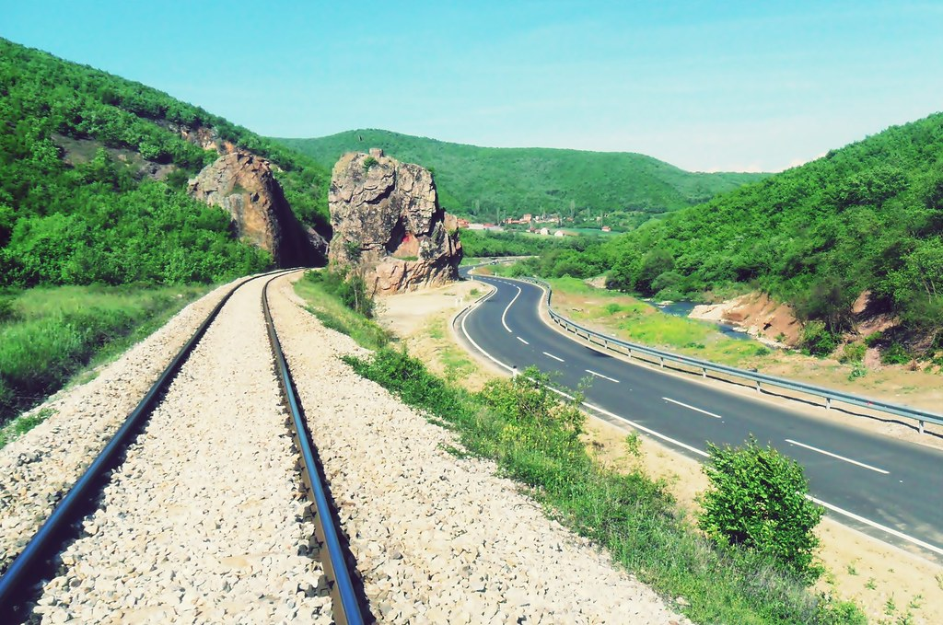

The main activities of INFRAKOS
INFRAKOS has started the year 2023 facing many challenges, but owing to the maximum commitment of the staff, it has overcome them and is successfully overcoming them. However, the difficult financial situation, with or without the fault of INFRAKOS, is a continuous problem that has also affected the second quarter of the year. As usual, in the second quarter of this year, the main priority has been the maintenance and development of the railway infrastructure, to enable the traffic of passenger and freight trains without problems and safely.
The works on the rehabilitation of the 10 Railway Line should have been completed by December 30, 2022, while the elapse of time for the complete completion of the project has reached 114.9%, considering the high risk and the immediate need of this national project, INFRAKOS has carried out negotiations with the Contractor in order to find a solution on how to get out of the created situation in order to complete the project.
The works have continued to be realized in the second phase Fushë-Kosovë – Mitrovicë, where there have been significant developments in the works for the rehabilitation of this segment, the works are being realized according to the predictions.
Departments and other supporting sectors were maximally engaged in finance, real estate, development planning and human capacity building.
An especial emphasis has been given to cooperation and coordination of actions with the responsible institutions of the state related to the SAA, the Program of Economic Reforms, and the National Development Strategy. We have also worked with commitment to complete the tasks foreseen by the action plan of the Technical Committee on Railways of the Transport Community for the countries of the Western Balkans where we participated in two meetings that took place, one in Pristina and one in Tirana, completing and submitting on time all the information and various data requested by the relevant institutions.

Reporting
One of the many obligations of INFRAKOS is related to regular reporting to the Board of Directors and the responsible state institutions regarding the state of the company and the developments that occurred for certain periods of time.
During the second quarter of this year, INFRAKOS has drawn up the Report of the first quarter and the same, after approval by the Board, has been sent to the Unit for Policies and Monitoring of Public Enterprises, and the reports for the months of April and May 2023 have also been prepared and submitted, thus fulfilling the reporting obligations.

Visit of the members of the Board of Directors together with the Chief Executive Officer to the Croatian Railways.

From 31.05.2023 to 03.06.2023 the Board of Directors (members of the Board) together with the Chief Executive have visited the Croatian Railways:
- For the main challenges and opportunities faced by the Croatian railway services during the transition period and after the accession to the European Union, in changing regulations,
- The organizational structure of the company in general,
- The organizational structure and applied practice developed during the transition periods from the old to the new technology,
- Organization of maintenance of railway tracks and electronic equipment,
- Visit to the Central Station in Zagreb, Visit to the railway traffic management centre.
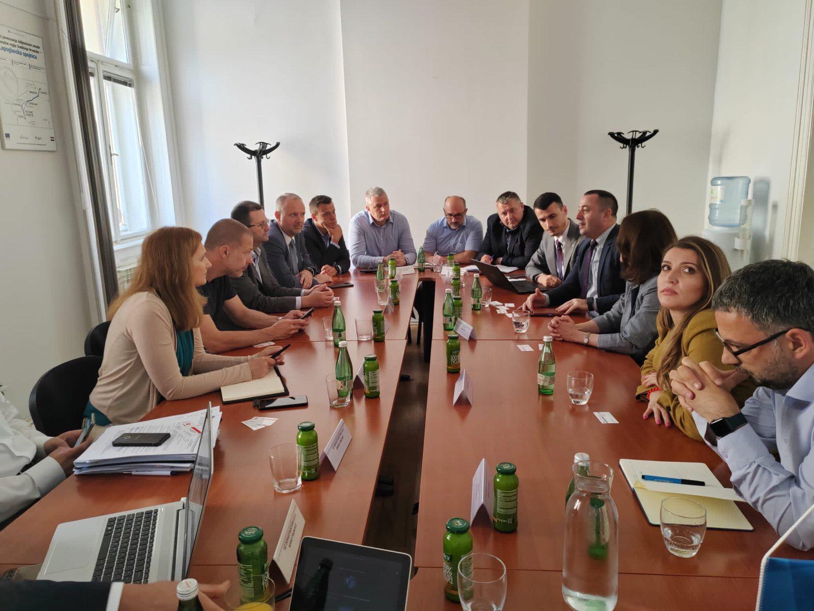

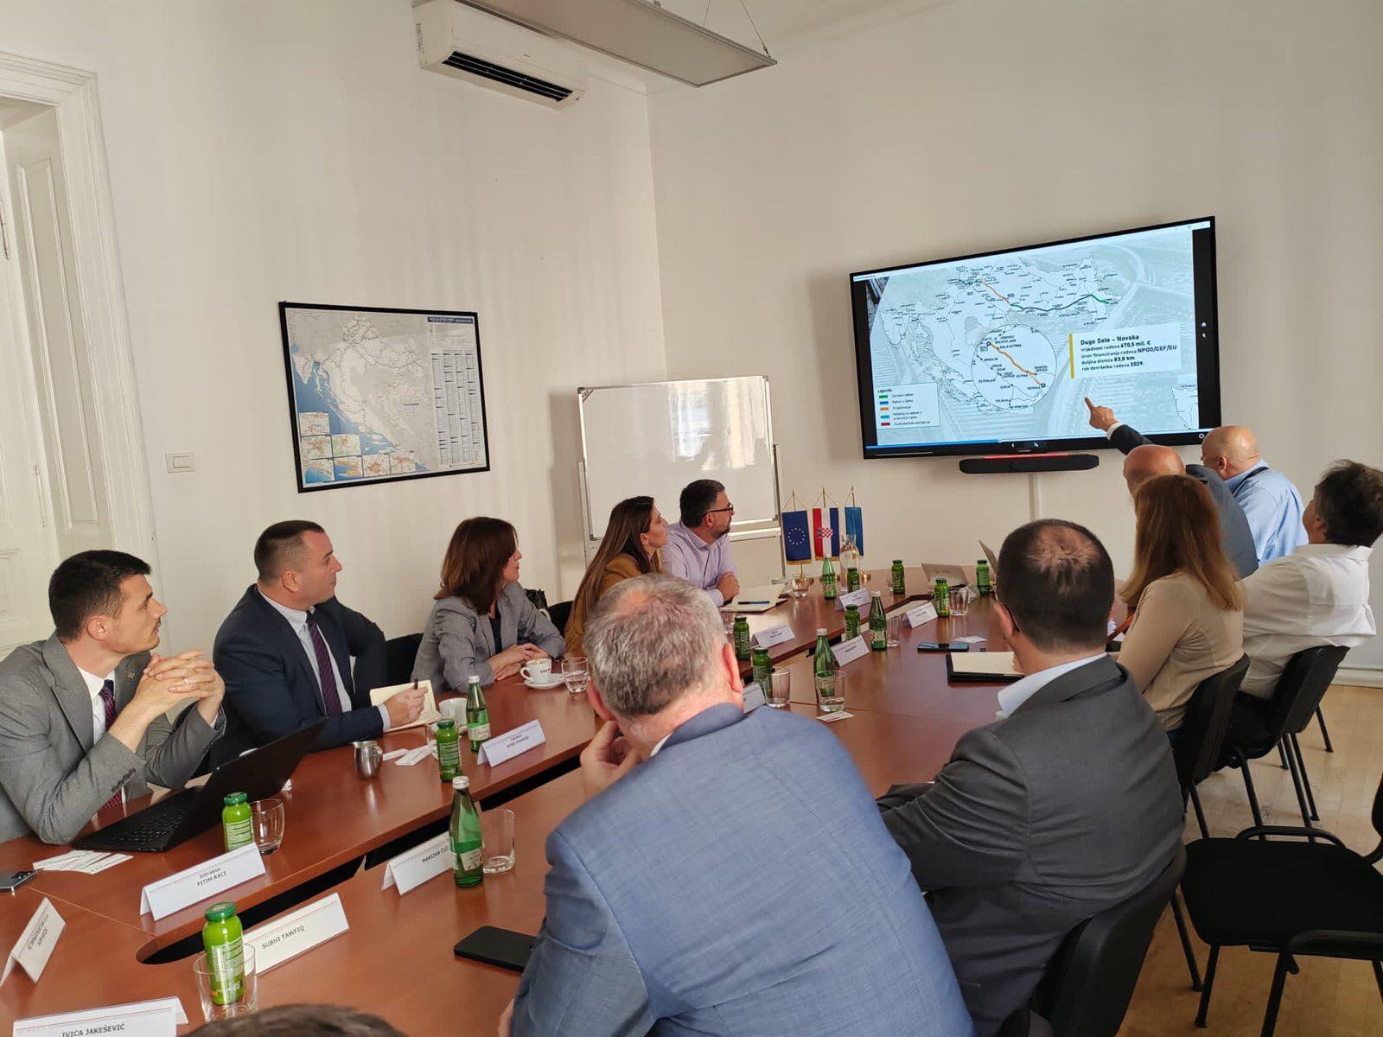

Railway line 10 (ten)
During the months of April, May, June, the contractor continued with works on the first phase of the railway line 10 (Fushë Kosovë - Hani i Elezit), where at the same time negotiations were held with the contractor for the continuation of the works and the postponement of the completion date by considering the construction of new bridges.

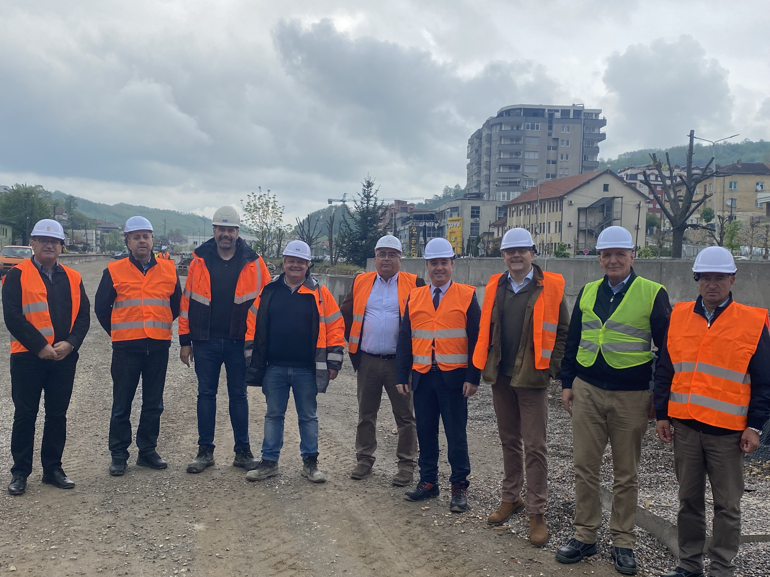

From these negotiations, the parties InfraKos and GCF (the contractor) jointly agreed to postpone the completion date for reaching an agreement for an appendix with No. 5 until 31.07.2023, while during this period the Addendum no. 4 of the Contract shall be singed. During the period April - June, the value of the work has reached: Financial absorption 63.17%, Physical progress on the line is 76% (60.493 km out of 79.57 km have been installed on the line). Materials (Rails, Sleepers, Switches, Ballast, etc.) are almost 99% in place. The delay between financial and physical progress is due to the superstructure materials, which represent 48% of the total project cost.
Realization and acceleration of works in the realization of the project remain an obligation of all parties engaged in this project, from the Contractor, the Supervisor, up to INFRAKOS.
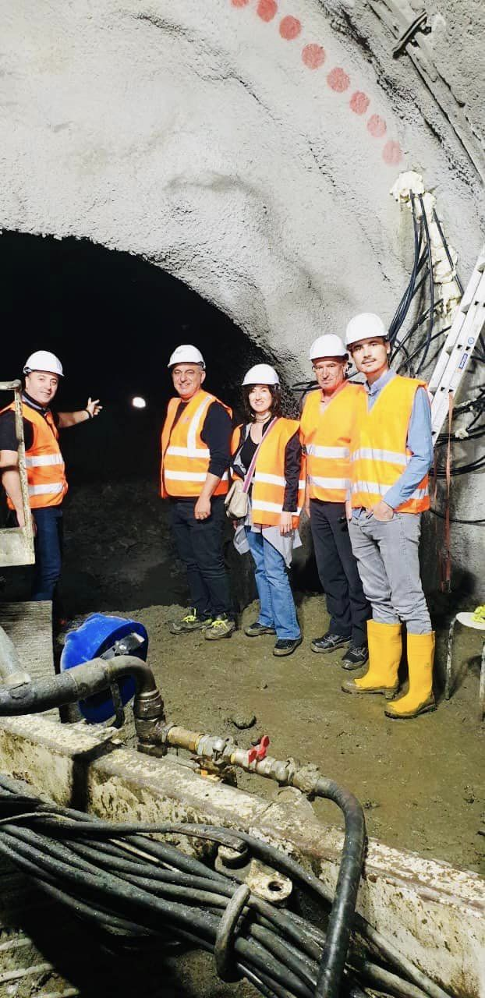During the second quarter of 2023, there were significant developments in the works for the rehabilitation of the second phase of the railway line 10 (Fushë Kosovë - Mitrovicë), the works are being developed according to predictions. Financial absorption during this period is 14.73%

Among the works and tasks carried out during this quarter, it is worth mentioning:
- The rehabilitation of the southern part (first phase) of this railway line (Fushë Kosovë - Hani i Elezit) has continued. As mentioned above, the negotiations for the signing of Addendum no. 4 have continued.

- The rehabilitation of the second phase of Fushë-Kosovë - Mitrovicë has continued.

- The detailed design and tender file for the project Rehabilitation and modernization of the third phase of the railway line 10 is being developed. Regarding the detailed project there have been some developments, the change from IPF9 to IPF11, Due to the changes from IPF9 to IPF11 the project delivery date is expected to be in Q4 2023, it is a prediction but this always depends on the political situation in this area. During this reporting period, the Methodology Proposal was submitted to the EBRD Bank, where comments were received on the same from the Bank in regard to environmental issues. These comments are being reviewed by IPF 11 for Bank approval.

Infrastructure maintenance
During this quarter, all sectors of INFRAKOS have had great commitment in the maintenance of the railway infrastructure, especially in the time of high temperatures, so that the railway traffic could be developed without a problem. Infrastructure railway has been in a state of readiness with an increased supervision, so that the railway traffic develops without problems. In addition to the activities mentioned above, a large number of other activities related to the maintenance, development, better functioning and in general to increase the performance of INFRAKOS have been developed. It is worth noting that also during this quarter there was a closure of the railway line (Fushë-Kosovë - Hani i Elezit, Fushë-Kosovë - Mitrovicë) due to the execution of works in the general rehabilitation of this railway segment.

The organizational structure of INFRAKOS

The organizational structure of INFRAKOS during this quarter of this year has not undergone any changes.
In the figure below, the organizational chart of InfraKos' functioning is presented.

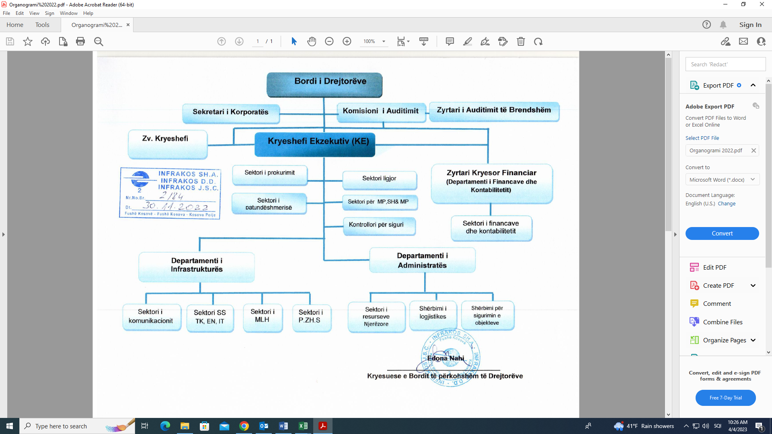

In the second quarter of 2023, INFRAKOS S.A. started with a staff of 251 employees. However, there have been some changes in the number and status of employees. One employee has retired, while we have had no cases of death. Three other employees have terminated their employment. In this reporting period, the Board appoints the CFTO of the enterprise based on the competition. As a result, at the end of June, INFRAKOS J.S.C. has got a staff of 241 regular employees. In addition to them, we also have four members of the Board with a mandate, making the number of employees reach 245.

Infrastructure Department

Traffic sector
During the months (April May June) 2023 the traffic sector has been dedicated to providing services to railway transport operators, such as TRAINKOS and RAILTRANS, in particular, the department has worked on monitoring and regulating the safe movement of trains, taking care that all the needs of passengers are met and the exact implementation of the train time-table. As for the movement of freight trains during this quarter, we realized one movement of freight trains.
By working with a commitment of 24hrs a day, the Traffic sector has made it possible during these three months not to have any delays or cancellations of trains due to its work. Each request from the transport operators TRAINKOS and RAILTRANS, (in particular TRAINKOS) for the insertion of trains into traffic that were foreseen in the train time-table or requests for extraordinary paths were immediately fulfilled.
This continuous and dedicated commitment of the traffic sector has made for running of trains to be safe and efficient in this quarterly period.
Other commitments of the transport sector are presented as follows:
- Management of basic data for the movement of trains (number of passenger trains, freight, extraordinary cases, track access charges, etc.);
- Regular education of the executive staff according to the relevant regulations;
- Technical control of switches together with other departments;
- Technical inspections of railway stations;
- The completion of four level crossings protected by automatic barriers on the Fushë Kosovë-Pejë line. Licensing of these level crossings is expected from the RRA.
It is worth noting that during the months of April, May and June on the Fushë Kosovë-Hani i Elezit railway line to the border with North Macedonia, there was no train traffic since September 2022 where we had a complete closure of the line due to the execution of project and demolition of tunnels 6 and 7.
The challenge of this department remains the lack of executive staff for the regulation of railway traffic.

Number of trains
The number one priority of this department during this quarter has been the organization of the passenger and freight trains traffic along the railway lines.
The following tables present the data on the number of passenger and freight trains traffic in the second quarter of this year, comparing them with the same period of time in 2022.

TABLE1. Number of passenger trains during Q2 2023
Comparison of trains | Passenger trains
Comparison of trains | Number of scheduled trains | Regular trains | trains  ad hoc |  | Revoked trains | The number of trains carried out
 | 1 | 2 |  | 3 | 4=1-2 | 5=2+3
Q2-2023 | 546 | 544 |  | 2 | 2 | 546
Q2-2022 | 546 | 546 |  | 4 | 0 | 550
Difference (2023-2022) | 0 | -2 |  | -2 | 0 | -4

TABLE2. Number of freight trains during Q2 2023
Comparison of trains | Freight trains
Comparison of trains | Number of scheduled trains | Regular trains | trains  ad hoc |  | Revoked trains | The number of trains carried out
 | 1 | 2 |  | 3 | 4=1-2 | 5=2+3
Q2-2023 | 514 | 0 |  | 1 | 514 | 1
Q2-2022 | 652 | 0 |  | 9 | 652 | 9
Difference (2023-2022) | -138 | 0 |  | -8 | -138 | -8

According to the table above, it can be seen that the number of passenger trains scheduled in the second quarter of this year is the same as the number of passenger trains in the same period last year, however, compared to this period of this year, two trains have been revoked, whereas in the same period of last year there was a traffic of all scheduled trains.
Regarding the number of freight trains in the Q2 time period of this year, a drastic decrease in the number of trains can be seen, since as shown in the above table the number of freight trains is only one, this happened as a result of the works on the railway line Hani i Elezit – Fushë Kosovë and the interruption of the work of Feronikeli Ore Mining.

Number of accidents
The biggest concern and one of the main problems of the traffic sector are the extraordinary cases, or accidents that occur on our railway lines. The table below shows the accidents that occurred in the second quarter of this year, comparing them with the same period of the previous year.
TABLE3. Extraordinary cases Q2 2023
Extraordinary cases | Total number of accidents | Value of material damages | The number of injured persons | The number of fatalities
Q2-2023 | 4 | €910 | 2 | 1
Q2-2022 | 2 | €0.00 | 0 | 0
Difference (2023 - 2022) | 2 | €910 | 2 | 1
The table shows that we had a total of four extraordinary cases. Compared to the same period of 2022, it can be seen that we have changes in the number of accident cases where in this period we have had only two extraordinary cases. In these accidents, one person died and two people were injured. It is worth noting that all extraordinary cases are handled by the professional commission for extraordinary cases jointly by INFRAKOS and TRAINKOS, as well as the Kosova Police.
It is relevant to note that none of the exceptional cases mentioned above occurred due to INFRAKOS.

Track access service
The network access service has successfully monitored the continuous traffic of all rolling stock in the INFRAKOS railway network, calculating the invoices of track access charges as well as all other additional services provided by INFRAKOS to the operators of transport TRAINKOS and RAILTRANS. The following tables show the comparison of revenues for the second quarter of 2023 with the second quarter of 2022 for the operators TRAINKOS and RAILTRANS.

TABLE4.TRAINKOS revenues in Q2 2023
Time period | Revenue from passenger trains | Revenue from freight trains | Income from non-regular trains - ad hoc | Income from other services | Total revenues
Q2-2023 | 38,952.66 | 0.00 | 4.60 | 3,739.16 | 42,696.42
Q2-2022 | 38,995.36 | 0.00 | 81.41 | 4,177.77 | 43,254.54
Difference (2023-2022) | -42.70 | 0.00 | -76.81 | -438.61 | -558.12

TABLE5. RAILTRANS Q2 2023 Revenues
Time period | Revenue from freight trains | Income from non-regular trains - ad hoc | Income from other services | Total revenues
Q2-2023 | 0.00 | 0.00 | 0.00 | 0.00
Q2-2022 | 0.00 | 0.00 | 0.00 | 0.00
Difference (2023 – 2022) | 0.00 | 0.00 | 0.00 | 0.00

The reflection of the data in the above tables clearly shows that in the second quarter of this year there is a decrease in revenues from the TRAINKOS Transport operator, the TRAINKOS operator has realized €42.70 less, while the RAILTRANS operator during this period has been zero in comparison with the previous year were also realized €00.00.
This is inconvenient for INFRAKOS, as the company's main revenues depend on track access of these two operators for the transport of freight. In this period, the operator TRAINKOS has revoked all the regular trains scheduled with the train time-table. While the operator RAILTRANS has not foreseen regular freight trains for 2023. This decrease in revenues from network access by transport operators represents an additional financial problem for our company.

Freight terminal
In this quarter, similar to last year, unfortunately, the number of containers transported to the terminal was zero, which automatically affected the decrease in the terminal's revenues for the services provided.

TABLE6. Revenues at the freight terminal in Q2 2023
Time period | Number of containers | Income from crane | Forklift income | Income from boarding passes | Total revenues
Q2-2023 | 0 | 0.00 | 0.00 | 0.00 | 0.00
Q2-2022 | 0 | 0.00 | 0.00 | 20.00 | 20.00
Difference (2023-2022) | 0 | 0.00 | 0.00 | -20.00 | -20.00

Railway lines maintenance sector
During the second quarter of 2023, the RLM sector was engaged in the maintenance activities of the railway lines and other supporting infrastructure so that the train and other rolling stock traffic is done without problems and with maximum safety. The RLM sector, despite the company's financial difficulties, has managed to maintain a satisfactory level in the maintenance of the existing railway infrastructure, including railway tracks with all their supporting infrastructure, bridges, tunnels, culverts, water conveying channels, loading platforms / freight unloading, level crossings, as well as all other facilities for the provision of railway services.
Along this route, due to high temperatures, there were deformations of the tracks and thus, the railway line maintenance sector has reached the identified places, they have taken all the necessary actions to repair and restore the previous condition of the track.
During this time period, the main tasks carried out in this quarter were presented.

Track geometry adjustment

During Q2 of this year, a regular inspection of the railway and accompanying facilities was carried out according to the monthly planning, based on the existing regulations. Inspections are carried out as visual inspections of the railway and objects along the railway lines by walking and avoiding identified deficiencies in the shortest possible time. A great deal of work has also been done in monitoring the condition of the tracks, so after identifying possible deficiencies, immediate intervention was made with the machines and maintenance personnel to avoid all breakdowns by adjusting the tracks according to the required standards.

Adjusting the geometry of the track according to direction and levelling with manpower and plasser machines
One of the main tasks during the maintenance of the railway lines is related to the adjustment of the deformation of levelling, direction and the planning of the ballast in the railway lines. In order to have safe lines for the transportation of passengers and freight, during this quarter regular maintenance was carried out on all railway lines in operation, maintenance was performed by Plasser machines.

In the following pictures is shown the condition of the track deformations and the condition after the intervention and rehabilitation of the track in the open line.

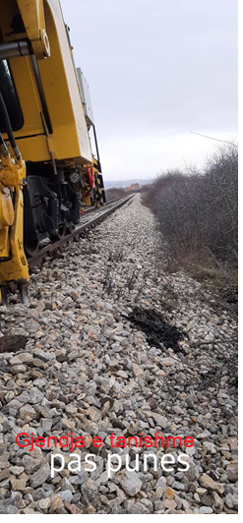
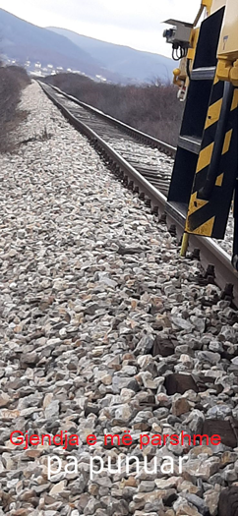
The condition before the intervention The condition after the intervention

Maintenance and inspection of switches
The sector for the maintenance of railway lines has performed a visual inspection of the switches three times a month and once by measurement. Together with the sector of electro-technical activity and the sector of Traffic, has conducted the technical inspection of the switches once a month. On the railway lines which do not have regular traffic development, inspections were conducted according to Regulation 314.

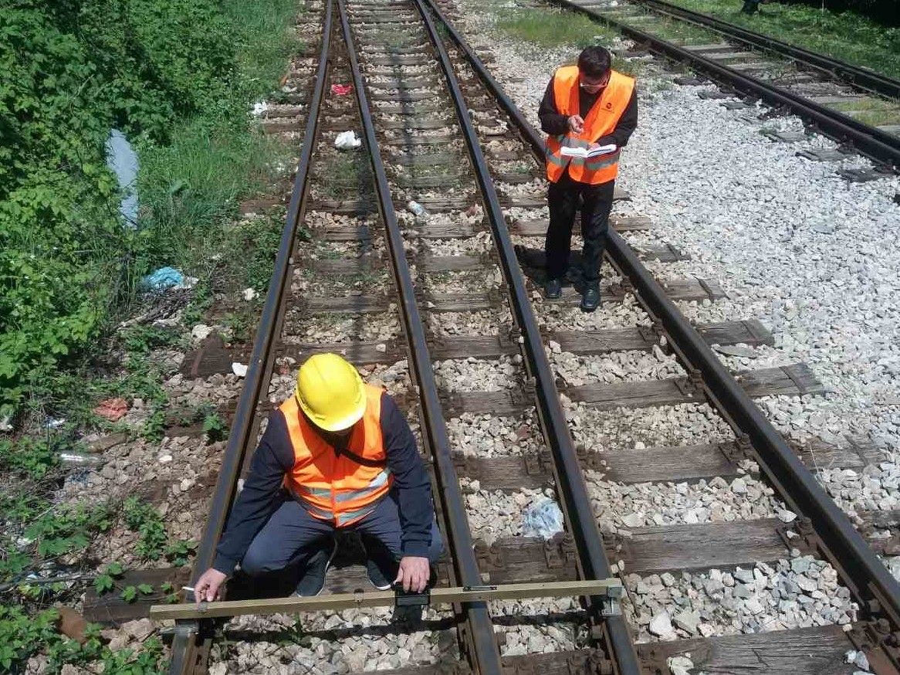

At this position of the works, the adjustment of the deformations of the levelling, direction, damaged parts and the planning of the ballast in the switches of the railway stations are performed as well. This work has been carried out quite successfully using the Plasser machine which enables such a thing. This maintenance has guaranteed a safe traffic for passenger and freight trains.

Replacement of obsolete sleepers
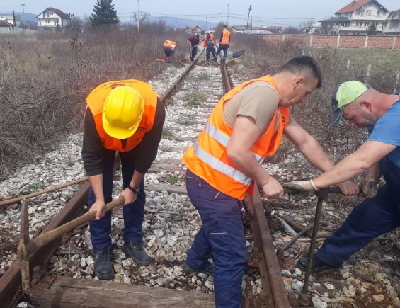
One of the most important tasks in the maintenance of the railway infrastructure is related to the regular maintenance and the avoidance of deficiencies in the railway tracks, including the replacement of obsolete sleepers which compromise the safety of railway traffic. During this quarter, the regular replacement of outdated sleepers on the open line and rails of the railway station was carried out in order to guarantee the maximum safety of train traffic.

Regulation of level crossing areas
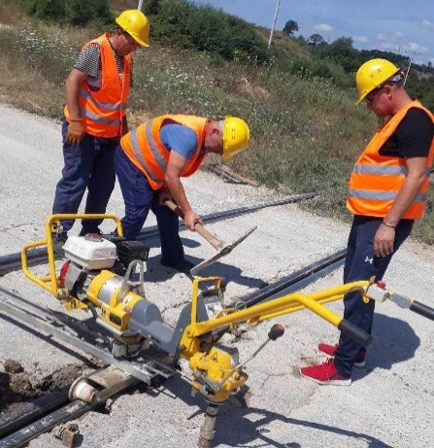
Seeing that most of the accidents occurred and are occurring at railway-road level crossings, then one of the high priority tasks during this quarter was related to the regulation of the level crossing area. This work has been successfully carried out and all the fixed crossings are now at a satisfactory level which allows for easier traffic of road vehicles. In this photo, the employees are shown adjusting and levelling the road-rail crossing.

Cleaning of free profile and water conveying channels
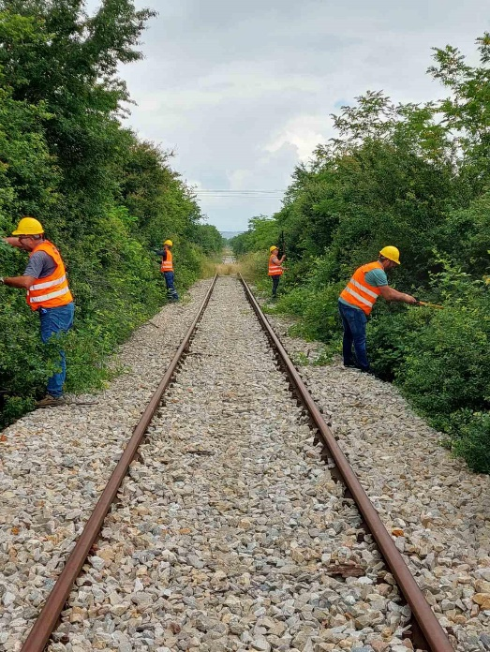
In the second quarter of 2023, continuous cleaning of the free profile was done on all railway lines where trains are operating so that the railway lines guarantee the maximum safety of train traffic. The RLM sector has a long experience and sufficient expertise to carry out such maintenance and this is done according to the standards and regulations in force.

Lubrication and refinement of bolts
The maintenance of the reinforcing parts of the tracks is a work of particular importance, as it ensures that the track has the required parameters to guarantee the safety of train traffic. Therefore, one of the works carried out during this quarter is also related to the lubrication and strengthening of the rail retaining bolts on the rail sleepers, a work which is carried out continuously.

Ballast planning
The adjustment of the ballast prism is carried out on the main line and through the switches with the SSP 103 machine and with manpower. In the period April - June 2023, work has been carried out on all railway lines.

Electro-technical activity sector
The electro-technical activity sector has successfully achieved the objectives foreseen by the Action Plan which was prepared within the Business Plan for the year 2023. The main objective of this sector was the maintenance of SS, TK, EN and IT equipment so that they successfully carry out the mission for which they are dedicated. Within this objective, the sector has taken continuous actions, quickly avoiding obstacles by intervening out of working hours so that there are no problems during the train traffic.
The objectives of the EA sector in this quarter were:
- Improving the safety of railway traffic;
- Regular and functional maintenance of SS, TK, EN and IT equipment;
- Follow-up of the Railway Rehabilitation Project;
- Supply of spare parts for the level crossing and return to functioning of the level crossing in Bardh;
- Budgetary expenditures in the sector (April, May and June 2023);
Since the safety signalling (SS), telecommunication (TK) and energy (EN) equipment are spread over the entire railway network, these equipment constantly have various problems due to third-party influences on these equipment.
In this quarter, all the services of this sector have successfully managed to carry out the planned tasks, including the signalling-interlocking, energy telecommunications and IT equipment, although in difficult conditions, due to the lack of spare parts, the equipment throughout time have been in full operation.
Due to the construction works in the rehabilitation of the railway line, the SS systems have been disconnected at the stations from Fushë-Kosova - Mitrovicë. The disconnection of the SS devices came with the Ordinance No. 100 dated 16.02.2023.
SS equipment and the Lipjan, Bablak, Ferizaj, Gurëz, Kaçanik and Hani i Elezit stations are now out of function, whereas with the beginning of the second phase, the stations from Fushë Kosova - Mitrovicë are not provided with a signalling system, by order are also disconnected level crossing equipment protected in the station area that are interconnected with travel routes. Due to the works, these outdated systems cannot be returned to use, the safety of these stations, until the installation of new systems, will be carried out manually.
From now on, the regulation of the train traffic at the station is done as per the traffic regulations in cases when the signals are out of order.
The type of interventions for the elimination of obstacles and some of the main tasks carried out in this time period are listed below:
- Monthly inspection of switches together with the department of traffic and RML across the railway lines in operation;
- According to the need with the spare parts available through the existing SS, TK, EN and IT systems;
- The adjustment and repair of automatic level crossings, especially after breaking half barriers by careless drivers, it is worth noting that the level crossing in Bardh is back in operation, while the level crossing in Qikatove remains out of order due to the lack of a spare part, a new barrier is installed. at level crossing 1 in Klina and as a result this level crossing is back in operation;
- The relays were dismantled in Mitrovicë, Vushtrri, Prelluzhe and Obiliq;
- Engagement in the drafting of the Terms of Reference for the level crossings that are planned to be secured automatically;
- Maintenance of internal electro-relay equipment as well as voltage supply equipment by replacing damaged elements;
- Repair of defects in radio system antennas;
- Continuous avoidance of obstacles in the telephone system in offices and railway stations;
- Installation, maintenance and avoidance of obstacles in the video surveillance system of the stations;
- Elimination of obstacles in the energy system, including the lighting network, electrical installations, transformer stations, generators, laying of energy cables, and so on;
- Testing optical cables and avoiding problems to them;
- Regular effective maintenance of IT equipment and network
- Increase in security level of the Information Technology system
- Computer equipment has been assembled, installed and configured according to the needs and requirements of InfraKos officials.

Planning, Development, Standardization and Safety Sector
The PDSS sector, during Q2 2023, has continued its work with the aim of ensuring the improvement of the sector's performance in order to serve the interests of the company. This has been a constant goal to meet the criteria and needs for the development of the railway infrastructure.
This report reflects on the activity of the PDSS sector staff, including the most important developments, it reflects the work carried out in the quarterly period. In this period, the implementation of the sector's annual work plan has been continued and the work related to this sector has been monitored, providing the sector with a high performance in serving the interests of the company.
The objectives of the sector during this period were as follows:
- Building human capacities towards increasing the safety, quality and effectiveness of the railway infrastructure;
- Establishing cooperation within the company, with local and international institutions in order to increase safety and modernize railway lines;
- Research of developments, achievements in the technology of railway systems and possible proposals for their implementation;
- Compilation of financial analyses based on budget frameworks and projects.
The main activities and the results achieved are presented below:
- Providing professional support in the realization of various requests at the company level and tasks arising from management meetings;
- Professional support was provided in meeting the requirements from the OPM for the first contribution/input of the institutions of the Republic of Kosova for the CEO Report for Kosova - 2022;
- Engagement in periodic reports regarding the KPDP;
- Analysis of energy consumption for heating in railway stations in Pristina and Fushë Kosovë;
- Response to the requests of the Transport Community for the project "Assessment of the railway market in the Western Balkans in terms of capacities, policies, economic and technical level of development of the segments of freight and passenger transport" for Kosova
- Engagement in drafting the document "Current projects, challenges and overcoming them"
- Commitment to providing comments on documents according to the requirements of other sectors;
- Contribution to the drafting of the MoESPI memorandum for capital projects;
- Updating the SMS Manual;
- Continuation of Part A and B Security Clearance until March 28, 2028;
- Processing and drafting of the Annual Security Report.

- Administration department
The General Administration Department has developed a considered activity during this quarter of 2023 in an effort to fulfil the objectives of this department and the company as a whole. In each sector and service, continuous work has been done to achieve the planned objectives and this has been achieved quite successfully.
  - Personnel Sector
There has been continuous engagement in the administration of personnel and other tasks, with the aim of achieving the objectives. The completed tasks of this sector are presented in detail in the following text.
This sector has actively worked and is working in the management of human resources, successfully carrying out all the tasks foreseen with the business plan, respectively with the company's action plan.
The objectives according to the business plan for which there was maximum commitment for their realization are presented below:
- Regular management of human resources (employment, dismissal, retirement);
- Salaries and other compensations of employees;
- Discipline at work;
- Providing necessary services and information to employees and interested parties;
- Planning and administrative supervision of the annual leave usage.
Kosova Railways Infrastructure InfraKos J.S.C., in the quarter (April-June) of 2023 it started with 247 regular employees and four board members, while with the board members the number of employees reaches 251 workers, we can say we are at the minimum possible number of employees, especially in the Infrastructure sector. While we complete the Q2 period, with 245 employees, including the four members of the Board. In this quarter, 8 employees have retired whereas we have no deaths.
The structure of employees on 30/06/2023, depending on the categories, is as follows:
- There are 241 employees with a regular employment relationship, of which 236 have employment contracts for an indefinite term, while 5 senior officials have a contract with a fixed term.
- Men are 225 employees and make up 93% of the total number of employees
- There are 16 employed women and they make up 7% of the total employed
234 are Albanian employees and make up 97% of the total number of employees
- There are 6 Serbian employees and they make up 2.6% of the total number of employees
- Ashkalinje and Roma have 1 employee and make up 0.4% of the total number of employees
- We have a total of 34 workers with primary school or qualified by Railways
- With secondary school, we have a total of 135 employees
- We have a total of 6 workers with high education
- We have a total of 66 workers with superior education
    - Regular Human Resources Management (hiring, dismissal, transfer, retirement, etc.)
HR have prepared the registers of active workers, workers who retire during 2023, work experience, annual, sick and status leave, and many other data as the basis of the annual work.
I emphasize that during this period of time the Resources have been available to cooperate with the Labour Inspectorate by answering any request related to the complaints submitted to InfraKos and providing them with the necessary documentation according to their requests.
Employment - During the second quarter of 2023, INFRAKOS based on the public competition, the CFTO has been elected with full mandate by the Board of Director.
Vacancy announcement - the vacancy for three train driver positions was announced and due to the lack of candidates, the vacancy has been cancelled.
Intern- during this period we have admitted a free intern in the traffic sector.
Transfer– In this quarter, two transfers from maintenance to the logistics sector were conducted.
Termination of the employment relationship - During this period, we have had eight retirements and three voluntary terminations of employment.
Discipline at work – HR has issued written warnings to the employees for non-compliance with the working hours recorded by the Chief Executive and the Director of Administration. After the pronouncement of these remarks, the discipline at work has improved significantly.
Leave without pay - During this period, leave without pay has been allowed for three employees:
Staff contract- During these months, employees were provided with contracts and there are also positions as acting. The positions as acting will continue to perform their duties in the positions as before.
Salaries and other compensations for employees- Regarding documentation (record of working hours, night shift, overtime, weekend, holiday work, annual leave, sick leave, status leave, etc.) sent by Human Resources to be processed in the calculation of salaries, each document is based on the law and other normative acts which are in force.
Providing necessary services and information to employees and interested parties - During this quarter, human resources have continuously carried out work on equipping employees, former employees, members of their families and third parties with documentation for their personal needs.
Follow-up of annual, medical and other status holidays - during this three-month period, human resources also dealt with the management of the workers' annual vacations. Human resources have regularly implemented the requests of employees for annual leave. Employees are continuously required to respect the legal deadlines for annual leave usage.
    - Registry office and archive
In the work protocol of the INFRAKOS registry office during this period, the following subjects of various natures circulated:
The input requirements are | 85
Court cases | 62
Incoming invoices | 305
Cases processed internally and distributed externally | 249
Cases processed internally and distributed internally | 90
Delivery by post | 58
Property rent contracts | 22
Employment contracts | 180
Applications for the position of Certifying Officer | 3
Applications for Train Driver | 5

From the Internal protocol, in this time period, the following ordinal numbers were put into service:

No. 2 | BOARD
No. 3 | Legal office
No. 4 | Contracts for employees
No. 5 | Decisions on annual leave
No. 6 | Certificates
No. 7 | Incoming invoices
No. 8 and 9 | Registration of documents for the rehabilitation of the line Phase 1 and 2

    - Logistics service
The Logistics Service has developed a considered activity during these three months in an effort to fulfil the objectives of this service. Each unit and the entire service has worked continuously to achieve the planned objectives, despite all the difficulties encountering in this period due to the condition and age of the vehicles in possession. Despite this, the maintenance of the vehicles during this period has successfully met the objectives. Regular servicing of all vehicles was carried out. The registration and insurance of the vehicles was carried out in the foreseen terms, taking into account that over 60% of the vehicles are outdated, and we have continuously monitored and avoided all breakdowns and repaired them in the shortest possible time.
We have cleaned them and recorded the kilometres travelled and oil costs for each vehicle and all together.
As for their use, we cannot say that we are satisfied, but this does not depend much on the service, but on the users, to whom we have warned many times for careful and rational driving.

    - Facility security service
This Service has fulfilled its duty tasks for this time period as well. The further challenge remains the lack of regular staff in this service, because we are forced to request additional staff from the RLM in order to cover the security points of the facilities.

Public relations and Media, Education, Protection and Safety at Work Sector

The Department of Public Relations, Education and Protection at Work is a new sector based on the organizational structure in the Kosova Railways Infrastructure J.S.C. "INFRAKOS" company, which includes the information officer and the service for Education, Protection at Work.
This sector supports the company from various professional fields of the aforementioned services such as: the field of information and relations with the public, permanent training for the executive staff, building the capacities of the staff, protection at work, etc.
Also, in terms of safety at work, we have a relatively good situation, of course we are constantly improving the working conditions of the staff and staff accommodation.
Detailed reports for each activity are presented below.
- Public and media relations
- Education, safety and protection at work
  - Public and media relations
During this period, it has successfully fulfilled its objectives, always following the path defined by the Action Plan for 2023, building media coverage strategies to improve the image of the INFRAKOS Company.
This sector keeps in constant contact and follows the electronic media continuously, as well as maintains and updates the company's website with the necessary data.
This sector also takes care of and reviews initial requests from third parties for access to infrastructure assets such as: filming, video spots, museum visits, etc.
In the field of relations with the media and the public of this company, we have managed to be more demanding in the protection of the image and reflection of the company in general.
The office for public relations and translations maintains constant contact with the media and researches materials in electronic addresses that are related to INFRAKOS, as well as deals with publicity in updating data on the company's website.

The following tasks have also been performed:
- All the daily work of the Public Relations Office has been completed.
- Appointments for remarks and interviews are arranged regularly according to requests.
- All daily newspapers, as well as electronic ones, are monitored.
- Actively, according to requests from third parties, initial requests for access to railway infrastructure assets are reviewed.
- All topics of special importance for InfraKos have been drafted, improved and edited
- Work has also been done on the fulfilment of certain duties and tasks.

During this Q2 period, materials published in the media related to the company were selected, materials which were photocopied, printed and stored in the archives of this office together with the relevant articles.

  - Education safety and protection at work
During this period, the action plan for the Q2 period was followed and all the tasks conforming to the company's internal acts were fulfilled.

Below are some general activities from this sector:

- Regular management and fulfilment of objectives from the Business Plan - 2023
- Regular training for executive staff
- Organization and holding of professional and periodical exams
- Personnel trainings
- Supervision of the state of health based on the regulation on health conditions
- Protection of health, environment and safety at work
- Protection from fire and natural disasters

    - Regular training for InfraKos Executive staff
The work processes in the Company and its specifics sometimes enable the optimal use of the existing staff, but that poses the need to be re-examined, analysed and defined from time to time in order to make the most of the existing capacity building.
The Service for Education/Training, Protection and Security has prepared the plan for the preparation-training of the executive staff of InfraKos based on the plan and instruction for training.
Permanent training is carried out based on the internal regulations and acts of the Company.
Based on the training, it has been held as follows:

Hani i Elezit, Ferizaj, Pejë and Centre in Fushë Kosovë, trainings were held for train drivers, head switchman, switchman and level crossing guard.

We have agreed to hold permanent trainings from the relevant departments since the sector in question lacks training officers in these fields.
The training for the executive staff during this period has been carried out with a satisfactory result. It is worth mentioning that in the last month of Q2, respectively in June, the request was initiated for the establishment of three commissions to hold periodic examinations for the three main activities of InfraKos, such as; The Traffic Sector, the Railway Lines Maintenance Sector and the Electro-technical Activity Sector.
    - Training for the staff of InfraKos J.S.C.
In the period April - June 2023, we as a sector have not initiated any request for capacity building (training) considering the difficult financial situation of the company.

    - Organization and supervision of regular medical check-ups of employees
In order for railway traffic to be as safe as possible, the Department has drawn up an action plan in order to constantly monitor the psycho-physical condition of the employees.
We do this through their regular-systematic medical checks, based on the conditions and criteria provided in the Regulation on the psycho-physical fitness of employees who directly participate in the traffic sector, the Signalling Sector, the Energy Service, the Terminal and CTC service

    - Protection of health, environment and safety at work
This sector regularly foresees the budget for the supply of protective clothing for the winter and summer season, but taking into account the difficult financial situation, we as a sector have made efforts for this project to remain justified in order to continue the implementation of this project with means from the budget of the Republic of Kosovo.
It is worth noting that during this period the RPMESW sector has committed to take all necessary actions to perform their duties and responsibilities.
    - Supervision and inspection
Regarding the supervision and inspection of workplaces and taking measures related to safety at work and the protection of employees' health, the Sector for training, safety and protection at work has identified the needs for improving these conditions in many railway stations and work units using the most appropriate methods benefited from the OSH project.
It is worth noting that the relevant sector during this period is dealing with the identification of the first aid equipment that are located in the stations, so far the Prishtina - Fushë Kosovë - Pejë line has been completed and the Mitrovicë and Hani i Elezit lines remains to be continued with.
    - Protection from fire and natural disasters
As for the risk of fire, this sector has initiated a procedure and the servicing and filling of fire extinguishers has been done, which increases the security level of fire protection.
Also, the relevant sector recommends the company to identify these fire extinguishers in cooperation with the emergency agency in testing them since these devices are old, and if there is a need to supply new appliances.

Real estate sector
The real estate sector is engaged in the work and management of properties. In this quarter, the property sector continued with the work and processing of 12 ongoing contracts and 7 new contracts. However, in the procedure of signing by the parties, there is only one continuing contract and 2 new ones.
Distribution of monthly invoices was also carried out.
The Property Sector has worked and submitted 9 letters for intervention and requests for the property background in all the municipalities where the property of InfraKos is located.
During these three months (April, May, and June) we have focused on fulfilling the obligations for all those customers who have not paid more than 3 monthly instalments and we have sent 91 Notices to customers about the payment of debts. Those who did not respond according to the notices we sent them to execution, and we are continuing with the same procedure.
We received 39 requests addressed to the property sector.
28 Consents are given,
3 Rejections,
11 opinions on the properties according to the requirements for placement in public auction.
1 Notice for non-subletting of property 1
Also, during this period of time, the public announcement for the rental of properties is being prepared,
We have also started with property tax invoices where we are having problems because they do not bring them complete, they bring invoices that do not belong to InfraKos.
3 cases were sent to the legal office
The Property Sector has worked continuously for the successful management of the property. In the following table we present you:

TABLE7.Main data for the second quarter in the property sector

c | Obilic | Vushtrri | Mitrovicë | Bardh i Madh | Lesac | Glogovac | Kline | Pejë | Xerxe | Prizren | Dobreve | Fushë Kosovë | Han i Elezit | Kaēanik | Ferizaj | Lypjan | Vranidoll | Prishtinë | Preluzhë | Podujevë | in total
The continuing contracts for premises are: |  |  |  |  |  | 1 | 4 | 3 |  |  |  |  |  |  | 4 |  |  |  |  |  | 12
The contracts in procedure are: |  |  |  |  |  |  |  | 2 |  |  |  | 1 |  |  |  |  |  |  |  |  | 3
New contracts for premises |  |  |  |  |  |  |  |  |  |  | 1 | 4 |  |  |  |  |  | 2 |  |  | 7
KK letter for intervention, Notices for the performance of debts, requests for property background, | 1 | 1 | 6 |  |  | 6 |  | 29 |  |  |  | 18 | 1 | 8 | 13 | 5 |  | 8 |  | 4 | 100
Property requests are: | 1 |  |  |  |  |  | 9 | 13 | 3 | 1 | 1 | 4 |  |  | 5 |  |  | 2 |  |  | 39
Requests with responds  from property are: | 1 |  |  |  |  |  | 1 | 2 |  |  |  | 1 |  |  |  |  |  | 1 |  |  | 6
The requirements in the procedure are: |  |  |  |  |  |  | 1 |  |  | 3 |  | 3 |  |  | 1 | 1 |  | 1 |  |  | 10
Consents from the commission are: |  |  |  |  |  |  | 4 | 7 | 1 | 3 | 1 | 4 |  |  | 6 |  |  | 2 |  |  | 28
Rejections from the commission are: | 1 |  |  |  |  |  |  | 2 |  |  |  |  |  |  |  |  |  |  |  |  | 3
Opinions about the auction properties from the commission are: |  |  |  |  |  |  | 6 | 5 |  |  |  |  |  |  |  |  |  |  |  |  | 11
Notices for not giving the property under lease are: |  |  |  |  |  |  |  |  |  |  |  | 1 |  |  |  |  |  |  |  |  | 1
Proposals, legal office for executor and usurpation further procedure |  |  | 2 |  |  |  |  |  |  | 1 |  |  |  |  |  |  |  |  |  |  | 3

- Procurement sector
The Procurement Sector during the second quarter of this year has paid special attention to the implementation of the company's supply procedures, thus guaranteeing financial stability, but also meeting the company's needs for regular work. Based on the procurement planning which is taken from the projects approved in the budget. The Procurement Sector has initiated the procedures according to the planned time for the tendering of the projects and their implementation. Therefore, during this period of time, the procurement department has dealt with two types of projects:
- Capital projects realized by the Consolidated Budget of Kosovo
- Supply projects realized from the INFRAKOS Budget.

  - Capital projects from the Consolidated Budget of Kosovo
According to the data managed by the Procurement Sector, from the means of the Budget of Kosovo, the requesting departments and units have started the activities of preparing the requirements and technical specifications of the relevant documents related to the publication of the capital projects which are expected to be realized according to the defined preliminary planning with the Business Plan 2023. Due to delays in signing the agreement for the financing of capital projects with the Ministry of Economy, in the second quarter two capital projects worth €65,000.00, were published.
  - Supply projects from the INFRAKOS Budget

Depending on the requests of the requesting units and based on the procurement procedures, during this period of time, the supply of all spare parts and other material required by all sectors of INFRAKOS was successfully carried out.

After receiving the approved requests, the Procurement Sector has developed procurement procedures and signed supply contracts for 10 different projects. The estimated value of these projects was €11,060.00, while the contracted value is €9,389.09. Whereas there are still 2 tenders in the procedure with an estimated value of €3,700.00.
- Internal controller
This report of the internal controller includes the quarterly control activities of all executive sectors for the quarterly period (January - March) of this year. This was done with the sole purpose that the quality of the services provided and the safety of the railway infrastructure be at the highest possible level.

Below are presented the main works carried out during Q2-2023:

- Regular control at stations;
- Regular control on railway lines;
- Regular control of executive staff.

The work of the internal controller during this period of Q2 has been very active and fruitful, thus conveying the necessary information regarding the existing situation on the ground and the work of all the executive staff, which has then resulted in the avoidance of eventual deficiencies and the raising of work efficiency from the relevant sectors. For the existing situation after each inspection, relevant reports have been drawn up and the responsible persons of certain sectors have been notified in writing.

8 Financial performance of INFRAKOS



- Financial performance of INFRAKOS
The Infrastructure of the Railways of Kosovo J.S.C., despite a considered number of difficulties, has had a maximum commitment towards the realization of the tasks foreseen in terms of maintaining the operation of the company, taking into account the poor financial situation which has led us in this time period as well.
Unfortunately, even in the second quarter, the expected subsidy was not made, so this made the already difficult financial situation extremely difficult. For better clarification, the following table presents the income and expenses for these three months, making a comparison with the same time period of the previous year.

TABLE 8. Revenues and expenses in Q2 2023
Comparison of income and expenses for February 2023 and 2022 |  | Realization  Q2 2022 | Realization  Q2 2023 | Budget  Q2 2023 | Difference | Difference
 |  | or | B | C | B - A | B – C
INCOME | Income from TM | 81,41 | 4.60 | 19,500.00 | -76.81 | -19,495.00
INCOME | Income from TU | 43,173.13 | 42,691.82 | 51,250.00 | -481.31 | -8,558.18
INCOME | Rental income | 211,233.54 | 238,767.21 | 187,000.00 | 27,533.67 | 51,767.21
INCOME | Other income | 24,841.22 | 51,419.51 | 41,875.00 | 26,578.29 | 9,544.51
INCOME | Deferred income from the BK grant | 220,005.00 | 230,929.20 | 207,500.00 | 10,924.20 | 23,429.20
INCOME | Network difference subsidy | - | - | 270,000.00 | - | -270,000.00
INCOME | Subsidy for the fee difference from ER | - | - | 616,984.00 | - | -616,984.00
INCOME | Total revenues | 499,334.30 | 563,812.34 | 1,394,109.00 | 64,478.04 | -830,296.66
EXPENSES | Equipment | 523.73 | 473.96 | 28,923.00 | -49.77 | -28,449.04
EXPENSES | Expenditures premise.  building | 19,116.72 | 3,887.43 | 21,823.00 | -15,229.29 | - 17,935.57
EXPENSES | electric energy | 16,993.96 | 20,170.31 | 47,000.00 | 3,176.35 | -26,829.69
EXPENSES | Oil | 7,299.99 | 5,861.24 | 15,350.00 | -1,438.75 | -9,488.76
EXPENSES | Oils, lubricators, etc. | 84.75 | 966.40 | 3,500.00 | -881.65 | -2,533.60
EXPENSES | Operating consumables | 699.96 | 2,349.61 | 9,500.00 | 1,649.65 | -7,200.39
EXPENSES | Repairs | 2,307.88 | 2,519.86 | 14,405.00 | 211.98 | -11,885.14
EXPENSES | Operational services | 182.40 | 2,176.27 | 2,330.00 | 1,933.87 | -153.73
EXPENSES | Official trips | 605.71 | 4,777.68 | 12,639.00 | 4,171.97 | -7,861.32
EXPENSES | Marketing and Publications | 1,765.28 | 627.03 | 13,656.00 | -1,138.25 | -13,028.97
EXPENSES | Office material and consumables | 615.73 | 5,021.14 | 7,905.00 | 4,405.41 | -2,883.86
EXPENSES | Phone / mail / internet | 2,262.51 | 2,349.05 | 4,540.00 | 86.54 | -2,190.95
EXPENSES | Hazard expenses | 2,624.80 | 2,693.01 | 71,185.00 | 68.21 | -68,491.99
EXPENSES | Represent/consumab. | 757.16 | 1,301.50 | 3,070.00 | 544.34 | -1,768.50
EXPENSES | Security | - | 1,974.30 | 5,450.00 | -1,974.3 | -3,475.70
EXPENSES | External staff | 940.00 | - | 6,350.00 | -940.00 | -6,350.00
EXPENSES | Staff and employees | 454,721.76 | 443,748.46 | 591,575.00 | -10,973.30 | -147,826.54
EXPENSES | Other operating expenses |  | 2,936.75 | 90,206.00 | 2,936.75 | -87,269.25
EXPENSES | Depreciation expenses | 264,739.94 | 267,169.13 | 267,081.00 | 2,429.19 | -88.13
EXPENSES | All expenses | 776,242.28 | 771,002.75 | 1,216,538.00 | -5,239.15 | -445,711.00
The difference  (Income – Expenses) |  | -276,907.98 | -207,190.41 | 177,571.00 | 69,717.19 | -384,585.53

Q2 2023 revenues | 563,698.18
Q2 2022 revenues | 499,334.30
Budgeted revenues Q2 2023 | 1,349,109.00
Realized operating expenses Q2 2023 | 771,002.75
Realized operating expenses Q2 2022 | 776,242.28
Planned operating expenses Q2 2023 | 1,216,538.00

  - The income
The revenues of INFRAKOS for Q2 2023 are presented in the table above and as usual these revenues consist of revenues from access to tracks (use of the network), revenues from real estate, other revenues and revenues from subsidies. Below is a description of the realized revenues for each segment, comparing them with the planned budget and the previous year.
    - Revenues from the use of the network
For the period Q2 2023, are realized 563,698.18€ in total or 40% of the foreseen budget amount of €1,394,109.00 compared to the period Q2 2022 we have a realization of €64,363.88 with an amount or expressed as a percentage of 113%.
    - Freight transport
For the Q2 period, the realization is €4.60, it is from the use of the railway network for the transport of freight, compared to the budget, only 0% of the budget was realized, while compared to the same period of 2022, we have a realization of 0.0%;
    - Passenger transport & services
The revenues realized from the use of the railway network for the transport of passengers and services is 42,691.82€ or 83% has been realized compared to the budget, while compared to the same period with the previous year 2022 we have 481.31€ less realization, while expressed as a percentage we have income of 1% less.
    - Rental income
During this period there realized 238,76721€ realized and that expressed as a percentage is 128% of the planning for this period where the planned budget was €187,000.00. So we have exceeded the realization of budget forecasts by 28%, whereas compared to the same period of last year 2022, the value of which was €211,233.54, or expressed as a percentage, we have 13% more income, this exceeding of budget forecasts is the result of great commitments for signing new contracts and renewing current contracts.
    - Other income
For this period were realized 51,419.51€, while the planned amount was €41,875.00 expressed as a percentage is 123%, so we have exceeded the realization of the budget forecasts by 23% more than the forecasts, compared to the previous year 2022, the value of which was €24,841.22, so we have exceeded the realization of the year 2022 by 207% in total.

    - Subsidy for fee difference-Government
For the second quarter, the subsidy planned for the difference between track access charges and the direct cost of maintenance of €616,984.00 has not been realized, so it is expected that this subsidy will be realized in the following months.

  - EXPENSES
    - Planned and realized expenses
Regarding the expenses, we can state that the expenses realized in this period are 771,002.75 €, which compared to the planned expenses of 1,216,538.00 €, are 445,711.00 € or expressed as a percentage, 36% are smaller. If we compare these expenses with the year 2022, the value of which was €776,242.28, then it turns out that compared to the previous year we spent €5,239.15 less than in the same period of 2022.
From the table above, it can be seen that all expenses were smaller than the planned expenses.
    - Comparison of income and expenses
Based on the above table of revenues and expenses, it can be seen that the difference between realized revenues of €563,698.18 and realized expenses of €771,002.75, where they are €207,190.41 higher than realized revenues.
    - Financial transactions
For the period (April - June) 2023, Kosova Railways Infrastructure JSC - INFRAKOS did not have any major transaction of assets worth mentioning. So, during these three months, only payments for operating expenses, as well as payments for supplies were carried out which did not have any great value that would be worth mentioning. What is more relevant is that all transactions are conducted according to the laws and other regulations in force for the management of finances.



9 Judicial proceedings

- Judicial proceedings of INFRAKOS
The legal sector of INFRAKOS during the period Q2 - 2023 has continued with the representation of the company in the Court, during this period the staff of the legal sector both in representations and in the enforcement procedure has developed an uninterrupted and professional work in order to protect the interest of the undertaking.

Activities and results

At the end of Q2, after the analytical review of the cases, we concluded that the situation in the Legal Office is as follows:
- At the end of the Q2 period, we have 344 active cases in legal proceedings (of which 272 are claimants and in 72 as defendants).
- During Q2, 13 claims were initiated;
- During Q2 there were 3 claims against InfraKos;
- During Q2, 3 criminal notifications were submitted;
- During Q2, 2 cases were completed in favour of InfraKos;
- In the enforcement procedure, at the end of the Q2 period, we have 210 active cases (of which in 191 cases we are the creditor, while in 19 cases we are the debtor),
- During Q2, 3 cases were initiated in the enforcement procedure in the amount of €13,702.29;
- During Q2, 2 cases were brought against InfraKos in enforcement procedure in the amount of €23,301.00.
- During Q2, 6 enforcement cases were completed (InfraKos as creditors 5, cases worth €15,021.14; InfraKos as debtor 1, case worth €11,238.62).
- The court has reached 9 judicial decisions, of which 6 are in favour of InfraKos and 2 against and 1 is procedural. (Cases in disadvantage, one has to do with non-recognition of compensation for lost profit from the use of property in Prizren and one with railway accidents where the company was declared partially responsible).
- 33 court hearings were held and work was done on the preparation of various legal cases and submissions.
- During this period, contacts were also maintained with the private executors engaged in InfraKos cases, and greater engagement in the execution of cases is continuously required. The delays are mainly due to the lack of data since we are dealing with old cases.
- The staff of the legal sector has a continuous commitment in updating the database for cases in courts and enforcement proceedings so that the management of the company can have a clear overview of the risk assessment and trends from the legal proceedings.

  - INFRAKOS court proceedings for the next quarter

In the next quarter, INFRAKOS is waiting for court disputes of the same nature, which are related to the payment of debts to the company, usurpation of property, housing issues, damage to infrastructure, proof of ownership and claims for expropriations compensations of the 1960s who present the issues with the highest risk, etc. There may be a new dispute of a different nature, but regardless of the type and number of disputes, the INFRAKOS Legal Office is committed to protecting and representing the interests of the company. Challenges and cases with high risk, two disputes related to the labour relationship, which in total can reach the value of about €130,000, as well as several cases for compensation from expropriations in the 1960s in the Municipality of Prizren.

  - Conclusions/suggestions and recommendations

During Q2 2023, the staff of the legal sector has also been engaged in other work and duties in the Company. Currently, the staff of the legal sector is coping well with the flow of cases in courts and enforcement. In order to continuously improve processes within the company, we reiterate that the legal sector suggests that:

- Adequate maintenance of customer files in the company with original invoices and other documents, proper and efficient management of rental contracts and payment terms due to the risk of statutory limitation and non-creation of debts is necessary for efficiency in legal procedures, especially the executive ones.
- To convey the level of debts from the property and finances in order to avoid legal problems and eventual statutory limitations and to strictly apply the contracts and regulations of the property.
- Debts with municipalities should be dealt with, including taxes.
- To take concrete and continuous actions to identify and prevent unauthorized users of the property, if there are any, in order to interrupt any term of winning statutory limitations and manifest the will of InfraKos for the management of the property.
- The issue of constructions on InfraKos property in Mitrovicë must be addressed, how to approach this issue.
- When renting, legal distances must be respected where there are eventual constructions.
- To handle the cases of debtors, especially those with high amounts and to make sure that they do not exceed the 3-year deadline without initiating legal procedures.
- To decide whether the company will handle the 3 requests and those that may come for the privatization of apartments.
- All cases of usurpation and debts should be processed in the legal office so that legal procedures can be initiated.
- InfraKos commitment to the maintenance of railway crossings, namely their visibility angles and illegal level crossings, should be addressed in management.
- To fully consider the legal procedures and internal acts of the company in order to avoid legal disputes that create a difficult position for the company.

In addition to regular work, the legal sector continuously coordinates actions with the property and finance department for the processing of cases in enforcement procedures, courts and the completion of files with the necessary documentation.

10 Performance enhancement

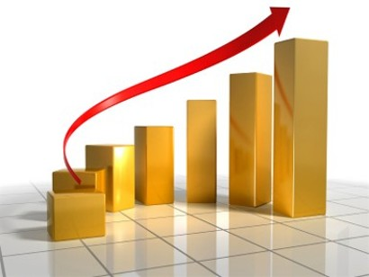

- Suggestions for boosting performance
INFRAKOS, as the Manager of the Railway Infrastructure, had the main priority in the second quarter of this year to the maintenance of the infrastructure so that the organization of railway traffic is carried out without obstacles and at the highest level of safety. The challenges we have encountered in this quarter have been very big and will still remain so, as long as the appropriate steps are not taken by the responsible government institutions. INFRAKOS has been and is maximally committed to the performance of tasks, therefore knowing the great importance of the railway, INFRAKOS expects that the relevant institutions will also do their tasks.
As usual, even in the second quarter of this year, the number one problem is related to the non-payment of the subsidy requested by the Government, which is affecting the operation of the company. For this reason, the immediate commitment of all institutions responsible for solving the financial problem of INFRAKOS is urgently required. This is about the Ministry of Environment, Spatial Planning and Infrastructure as well as the Ministry of Economy which according to the Law on Railways No. 04/L-063 are responsible for signing the Five-Year Financial Agreement with INFRAKOS. InfraKos asks these two ministries to review the Draft Five-Year Financial Agreement (2023-2027) and to sign it, so that the operation of railway transport is not affected.
Knowing that the situation in the second quarter in terms of revenues was not satisfactory and that mainly without the fault of INFRAKOS, because the main revenues of this company depend on the transport operators (TRAINKOS and RAILTRANS), then our suggestions for next quarter are as follows:
- The Ministry of Environment, Spatial Planning and Infrastructure in cooperation with the Ministry of Economy to fulfil their legal obligations for subsidizing INFRAKOS for the year 2023 thus covering the direct cost of infrastructure maintenance and the cost of uncovered operating expenses;
- The Ministry of Environment, Spatial Planning and Infrastructure in cooperation with the Ministry of Economy to sign the five-year financial agreement (2023 – 2027) which was drawn up on the basis of the seven-year business plan;
- TRAINKOS, as an operator of railway transport for passengers and freight to fulfil its obligations to InfraKos on time;
- Municipal and judicial institutions should engage much more in the protection of INFRAKOS property, which is usurped and misused by various physical and legal persons;
- The Ministry of Environment, Spatial Planning and Infrastructure to design, approve and implement genuine development strategies for the railway sector;
- INFRAKOS to urgently continue the undertaking of all measures for the collection of debts that others have towards this company;
- INFRAKOS to continue with the reduction of expenses with the exception of those related to the safety of railway traffic;
- INFRAKOS to complete the drafting of the property development strategy, a strategy that is of particular importance for proper property management and revenue creation;
- INFRAKOS to have maximum commitment in the realization of railway infrastructure development projects.

For more detailed information about court cases, enforcement procedure, financial values, refer to the database attached to this report.
For more detailed information about court decisions, see the list attached to this report.
. In 2014/15, the cases were transferred collectively from the Courts to the executors. Because we are dealing mainly with old cases, there are difficulties in securing personal data for debtors, this is causing difficulties in their proceedings.

